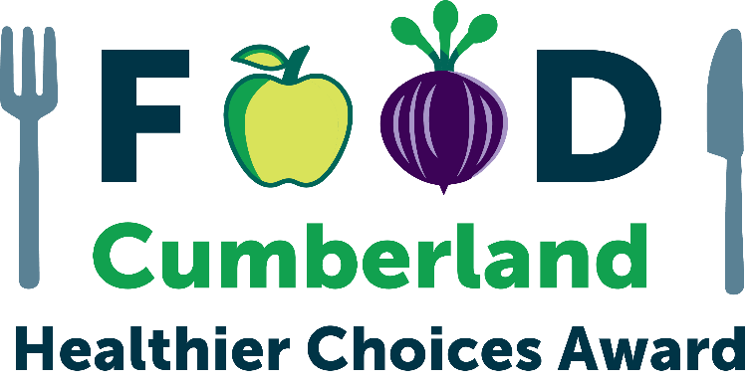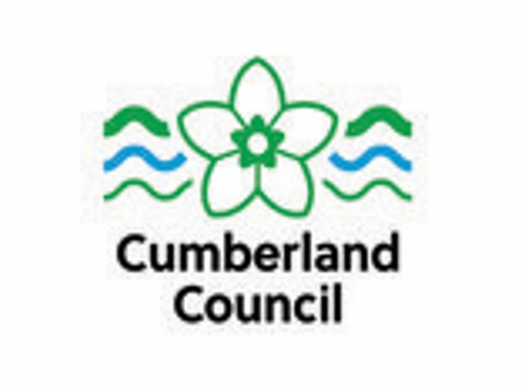

What is the Healthier Choices Award?
The Healthier Choices award promotes Early Years / Nurseries (0-5 years) that focus on healthier eating, environmental issues, and social responsibility. Sound like you? Then read on.
Healthier Choices is a scheme awarded by Cumberland Council for Early Years providers.

Benefits for your setting
-Providers will be supported to make positive changes to their menus, policies, and practice to support the health of your families.
-Providers with the award will be promoted by Cumberland Council and by partners across our Food Cumberland Partnership by promotion on our Food Cumberland & Council websites and social media platforms and throughout council buildings.
-Providers with the award will receive a promotion pack containing a certificate and other eye-catching materials to display in their premises to promote their good work.

How to apply?
There are three levels to our Healthier Choices award - Bronze, Silver and Gold.
The award is free to apply for.
You must have attained on the Food Hygiene Rating Scheme at your most recent inspection:
- at least 3 to apply for Bronze
- at least 4 to apply for Silver
- at least 5 to apply for Gold
Please complete this self-assessment form. The form is then sent to Food Cumberland’s Healthier Choices team healthierchoices@cumberland.gov.uk .
If you successfully qualify, you will receive your award during a short presentation. The whole process should take no longer than 1 month.
You can apply to the award at any time of the year and either for individual bronze, silver or gold or you can complete them all at once if you meet the criteria.
If you have any questions, please contact: healthierchoices@cumberland.gov.uk

Bronze Award Criteria 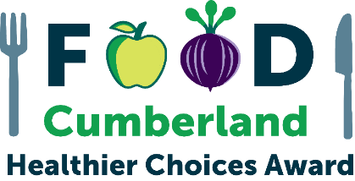

Please complete this self-assessment form by carefully filling in the information requested. If you need more space, please include any extra information on additional paper and return it with your self-assessment form. If any questions are not applicable to your setting, please write N/A. (if you have multiple settings, please submit one application per setting)

Please provide a copy of your menu with your assessment sheet.

If you require any further advice or assistance in completing this form, please go to Healthier Choices Awards - Coming Soon! | Food Cumberland or contact the Healthier Choices team by email at healthierchoices@cumberland.gov.uk.

Provider details

Provider Name
Provider Address
Manager/Owner Details
Contact Telephone Number
Email Address
Website
Type of Establishment (e.g. School Nursery / Maintained Nursery / PVI / Childminders)

Food Hygiene Rating Scheme
What is your current food hygiene rating?
(must be at least a Food Hygiene Rating of 3 for the Bronze award)

Nutritional information
How do you share with parents and children the nutritional value in each meal?

Do you consider the nutritional value throughout the whole day for children (in line with the Early Years Nutritional guidance)?

Early Years Foundation Stage nutrition guidance

Healthy Eating*
Do you follow the food & drink guidelines as stated in the EYFS Early Years Foundation Stage nutrition guidance
Do you only provide milk or water?

EYFS nutrition guidance states:
• Children should have access to water throughout the day.
• Provide only fresh tap water and plain milk to drink.
• Provide whole milk, semi-skimmed cow’s milk or unsweetened calcium fortified non-dairy alternatives for children from 1 year of age.
• Avoid skimmed and 1% cow’s milk. • Avoid sugary drinks (including fruit juices, squash and smoothies).
How do you share the importance of avoiding UPFs (ultra processed foods) e.g.:
if food is being brought from home
or
when food is prepared and provided by the setting, how do you ensure UPFs are kept to a minimum.

How do you ensure meals / snacks you provide take into account the Eatwell Guide
The Eatwell Guide - NHS

Do you include foods that nourish and are full of fibre (e.g. vegetables, pulses, wholegrains)?
EYFS guidance is to avoid food high in fat, sugar & salt (HFSS) like cakes, sweet and savoury pastries, biscuits, crisps, chocolate and other confectionary.

Fruit and Vegetables
What fruits, salad and vegetables do you provide for snacks & within your recipes?

How many portions of fruit & vegetables do you provide during the duration of a child’s session?

How do you inform parents / carers of what each child has had?

Salt
How is salt minimised in your food preparation?
e.g. not adding salt when cooking (i.e. when boiling potatoes, rice, or pasta), using black pepper or herbs and spices to flavour food instead, using homemade stock.
Please provide details

Sugar
How do you share with your families - information around foods / drinks high in sugar content e.g. high sugar levels in UPFs (ultra processed foods) such as pre-prepared children’s food / pouches / fromage frais etc.

How do you show the link between high sugar foods / drink and the adverse impact of the oral health on young children.

Allergens

How do you control allergens in your premises?
e.g. use of the Safer food, better business (SFBB) allergen information sheet / Food Standards Agency (FSA) allergen matrix / allergen information sheet / cleaning regime?
Guidance:
Safer food, better business (SFBB) | Food Standards Agency
Allergen guidance for food businesses | Food Standards Agency
Cumberland Council Allergen information - Food standards | Cumberland Council

Do you obtain information about allergies and dietary preferences when registering a new child to your setting?

Do you regularly check with parents / families about any updates around food allergens affecting their child/ren?
e.g. is it still the same or have there been any changes

How is allergen information made available to all staff & families e.g. menu, noticeboard, other signage, allergen matrix.

How do you share known allergens for individual children with all staff?

Are labels on prepacked products checked for the presence of allergens i.e. a 'may contains' type statement?
And are the labels retained on file for the lifetime of the food?
Have all employees involved in handling food, completed Food Allergen training?

Please provide details

Free training resources:
Online food safety training | Food Standards Agency
Allergen information for food businesses – Cumberland Council
Food standards | Cumberland Council

Environment
Please give details of any trade waste contract you may have, including, waste company name, frequency of collections, type of wastes and recycling collected?
Is food waste separately collected for recycling?

How do you minimise your impact on the environment? e.g. recycling, energy efficiency measures, minimising water waste.
Examples:
Taps not left running unnecessarily, switching off or turning down all energy using equipment when it is not being used, switching off lights when a room or area is unoccupied, dishwashers/washing machines only used when full, energy efficient bulbs used wherever possible, keeping the room thermostat temperature at the lowest comfortable level,
heating turned off before windows are opened.
Do you have hand driers in the toilets or paper towels?

Please outline how you actively discourage food waste?
e.g. batch cook / only defrost number of portions for each session

Do you champion local produce and feature it wherever possible.
Any examples?
Do you increase the amount of vegetables, pulses and wholegrains both on the menu and within recipes along with increasing vegetarian/vegan options in general.
This will help to improve the inclusivity of the menu, healthiness, reduce emissions and free up budget for the purchase of better quality, local/free-range/organic meat, fish and dairy products).

Can you give an example?

General
What steps are taken to ensure that accurate descriptions are given to all products?
e.g. homemade is made from scratch on the premises, meat products meet the minimum standards.

Where do you display business ownership details? It is legally required unless exempt.
Guidance -
Company and business names | Business Companion
All food handlers in your provision must receive adequate supervision, instruction and/or training in food hygiene for the work that they do. Please provide details

*N.B. for premises providing food solely for under 5's such as nurseries and childcare settings there is no requirement to use low fat products, it is preferable to use full fat dairy products, however low sugar and low salt options are preferable.

Silver Award Criteria

Please complete this self-assessment form by carefully filling in the information requested. If you need more space, please include any extra information on additional paper and return it with your self-assessment form. If any questions are not applicable to your provision, please write N/A.

Please provide a copy of your menu with your assessment sheet.

FHRS Rating
What is your current food hygiene rating?
(must be at least a Food Hygiene rating 4 for the Silver award)

Healthy Eating*
If you offer fried fish, is this lightly battered or crumbed?

Do you offer baked potatoes with low fat fillings? (e.g. cottage cheese, tuna with low fat mayo, beans)
Please provide examples
What bread options are available? e.g. 50/50, wholemeal, granary.

Do you consider the Eatwell Plate and the daily balanced nutritional intake for a child when serving snacks / meals

Please provide examples

Fruit and Vegetables
Has your setting made efforts to incorporate more vegetables into recipes? e.g. sauces, soups.
Please provide details

If you offer desserts, are fruit and fruit-based desserts available? e.g. whole fresh fruit, fruit salads, malt loaf or fruit cake.
Please provide details

Salt
Rather than salt, do you use herbs to enhance the flavour in your recipes / food
Please provide product details

Sugar
Has your setting made any efforts to reduce the sugar content of any food items?
e.g. by reducing the quantity of sugar or replacing sugar with fruit, spices or other healthier alternatives.
Please provide details

Fats and Frying
Do you use trimmed and unprocessed meat and poultry where possible?
Please provide details
Do you grill or steam any menu items in preference to frying?
Do you shallow fry menu items instead of deep frying?
Please provide details

Allergens
Do you offer an equally nutritious alternative if a child has an allergy in your setting?

Do you request a product specification from suppliers of foods that do not come with full labelling?
Do you request notification from suppliers about changes to recipes of prepared foods in relation to allergens?

Do you check all food bought in e.g. same item from different suppliers might have different ingredients?

Environment
Do you reduce waste where possible. Do you separate waste for reuse and recycling? e.g. card, plastic, glass, metal.

Do you have a separate food waste collection or on-site composting?

Have you or your team had any training on waste reduction where applicable?

Please provide details
Do you purchase cleaning products / washing detergents in bulk and in concentrated form, where possible?
Please provide details

Do you use refillable containers wherever possible? e.g. washing up bottles, soap dispensers, condiment pots.
Please provide details

Do you avoid using disposable products where possible i.e. single-use straws (please specify what they are made of), drink stirrers (wood or some other material – please say) and cutlery AND do you avoid using expanded polystyrene food and drink containers.

Please provide details

Guidance –
https://www.businesscompanion.info/en/quick-guides/miscellaneous/single-use-plastics
and
https://www.gov.uk/guidance/single-use-plastics-bans-and-restrictions

General
Have all employees involved in handling food, completed the minimum of Level 2 Food Safety and Hygiene training?
Please provide copies of certificates.

Gold Award Criteria

Please complete this self-assessment form by carefully filling in the information requested. If you need more space, please include any extra information on additional paper and return it with your self-assessment form. If any questions are not applicable to your business, please write N/A.

Please provide a copy of your menu with your assessment sheet.

FHRS Rating
What is your current food hygiene rating?
(must be a Food Hygiene rating 5 for the Gold award)

Promotion and Marketing
Do you promote healthy eating guidelines on your premises?
e.g. 5–a–day, the Eatwell Plate, reduced salt intake.
Please provide details

Is information given to families on provenance (origin of the food, where it is grown, raised or caught) especially when local produce is used (use of storytelling to promote importance is a good way to market local produce)
Can some of your ingredients (e.g. meat, dairy, fruit & veg) be traced back to the farm? Another good story to increase your footfall.
Buying British – do you ask suppliers to source from UK?

Can you track the % of British sourced foods you use?
Do you promote the use of seasonal dishes?
This could include the importance of the use of seasonal.

Healthy Eating*
Are all staff knowledgeable around the nutritional guidance and ensure they actively share with parents / carers the importance of a healthy balanced diet.

Please provide details of any applicable training, qualifications or experience

Free Nutrition information available on Food Cumberland Partnership website: Healthier Catering training:
Healthier Choices Awards - Coming Soon! | Food Cumberland

Salt
Do you avoid using MSG (Monosodium Glutamate) AND salt together in recipes, or reduce the amount of MSG used? (If appropriate for your cuisine)

Fats
Are English muffins / crumpets served without spreads / butter as standard.
An alternative could be full-fat cream cheese?

Allergens
When there are changes to the allergens in ingredients used, are menu indications updated immediately? If yes, please explain how staff are notified of these changes?
Is staff training in relation to allergens documented and regularly refreshed?
Please provide details

How are tables, highchairs and other equipment used by allergenic children cleaned before their use of it?

Environment
How frequently do you carry out checks and maintenance on water taps, and on fridge / freezer seals, to ensure they are kept in good repair to avoid energy / water leakage?
Please provide details
Do your suppliers take back packaging for reuse where available?
Please provide details

Are staff made aware of waste minimisation, water saving, and energy saving measures?
Please provide details

General

Are you signed up to the FSA (Food Standards Agency) to keep yourself and your team updated with FSA updates?
News and alerts | Food Standards Agency

It is deemed 'Best Practice' for Food Safety and Hygiene training to be refreshed every 3 years.
Please provide evidence

Do you welcome breastfeeding and bottle-feeding on your premises (if applicable) and offer smaller portions and healthier choices for infants.

Declaration

As an authorised person of the below-named provider, I verify that all information supplied above is true and accurate at the time of completing this self-assessment form.

Provider Name:
Print Name:
Signature:
Date:

After completion, please return to:
Healthier Choices Award
Food Cumberland Partnership
By email to – healthierchoices@cumberland.gov.uk
NB: Don’t forget to include a copy of your menu.

Or by post to:

Healthier Choices Award
Food Cumberland Partnership
Cumberland Council
117 Botchergate
Carlisle
Cumbria
CA1 1RD
NB: Don't forget to include a copy of your menu.

Further free guidance can be found here: Government website - https://www.gov.uk/

Data Protection:
In completing this form, you understand that Cumberland Council has a requirement to process your personal data.
Cumberland Council will only ever process your personal data where it has a clear lawful basis for doing so in full compliance with data protection legislation - UK GDPR and The Data Protection Act (2018). We will ensure the security and confidentiality of your personal data at all times.
For full details of how Cumberland Council handles your personal data please see our privacy notice here:
Data protection and GDPR | Cumberland Council

